HUMSHAUGH PARISH COUNCIL  Annual Parish Council Meeting  7.00PM on THURSDAY, 13 JULY 2023  AGENDA | 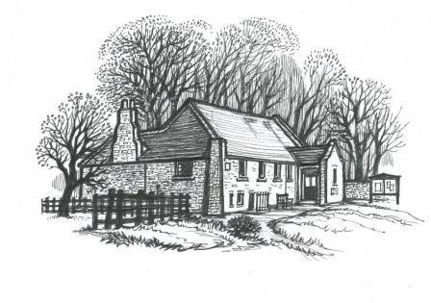

- APOLOGIES FOR ABSENCE

- CO-OPTION OF PARISH COUNCILLOR

- INTRODUCTIONS

- DISCLOSURE OF INTERESTS

- PRESENTATION: WATER QUALITY AND SEWAGE POLLUTION (NICK MORPHET) (limited to half an hour)

- PUBLIC FORUM

- MINUTES OF MEETINGS
  - a) Minutes Annual public (HPC) - 11 May 23.docx
  - b) Minutes Annual Bi-Monthly Parish Council (HPC) - 11 May 23.docx

- MATTERS ARISING
  - Parking at Humshaugh surgery
  - Local Transport Plan – confirmation of priorities Humshaugh Parish Council Feedback 2022-3.docx Draft 2023 Humshaugh LTP v2.xlsx
8.3 Clerks Report Clerks Report 13 July 2023.docx
  - Humshaugh Parish Council representative – Evans Trust

- UPDATE FROM NORTHUMBERLAND COUNTY COUNCIL – COUNTY COUNCILLOR NICK MORPHET

- PLANNING
10.1 Review of recent planning approvals
10.2 Review of recent planning applications – Ratification of the objection to the application regarding The Shielings (Ref. No: 23/01863/FUL | Received: Tue 23 May 2023 | Validated: Fri 09 Jun 2023 | Status: Registered)
10.3 The Paddock development

- FINANCE
  - Current Account Current Account 5 July 2023.xlsx
  - Deposit Account Deposit Account 5 July 2023.xlsx

- BUSINESS
  - Policy Schedule Review – Personal Data Information Asset Register Personal Data Information Asset Register.xlsx
  - EV charge point – EV Charge Point Update for PC 030723.docx
  - Post Office van

- COMMITTEES
13.1 Neighbourhood plan Notes Neighbourhood Plan Group (HPC) - 4 May 2023.docx

- REPORTS AND UPDATES
14.1 Humshaugh Net Zero – no report received
14.2 Evans Trust – no report received
14.3 Village Hall Village Hall Update.docx
14.4 Humshaugh Community Ventures Ltd (Village Shop) – no report received
14.5 Playing Fields Trust –meeting 9 July

- CORRESPONDENCE
15.1 Request for donation – Citizens Advice Northumberland
15.2 Community Chest – deadlines – 12th September and 12th January
15.3 North Tyne Youth Annual Report (sent separately)
15.4 Request for donation – Great North Air Ambulance
15.5 Citizens Advice Northumberland – information on support on offer re energy costs
15.6 Invitation to the Tynedale Local Area Committee Meeting 11 July
15.7 Rural Design Centre – confirmation of value of support received - £109.52.

- ITEMS FOR DISCUSSION AT NEXT PARISH COUNCIL MEETING

- DATE OF NEXT MEETING - 7.00 PM Thursday 14 September 2023, Humshaugh Village Hall - Bi-Monthly Parish Council meeting.

